Name:Vasavi S Puranik
USN:1BM24CS320

Employee Database
1.Using Scheme diagram, Create tables by properly specifying the primary keys and the foreign keys
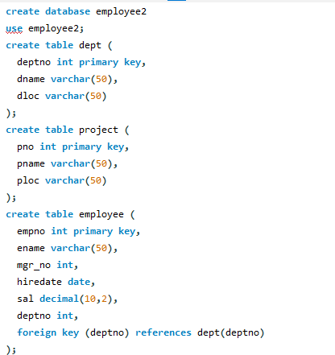
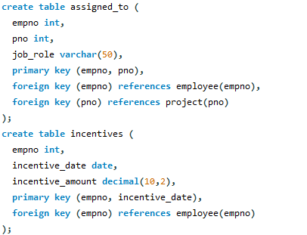
2. Enter greater than five tuples for each table.
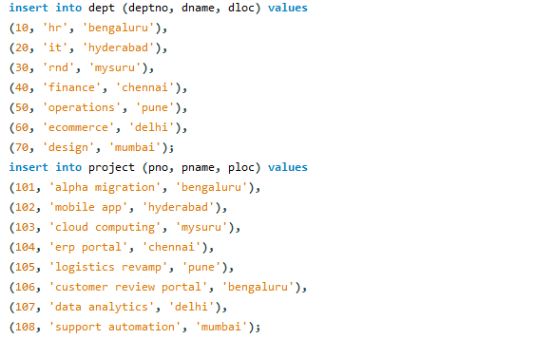
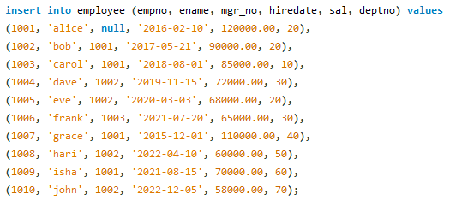
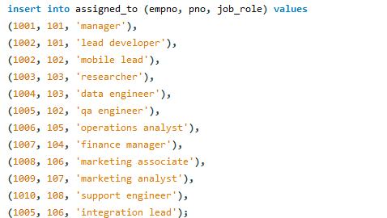
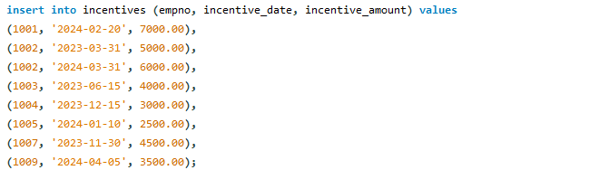
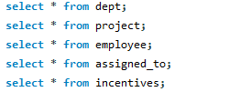
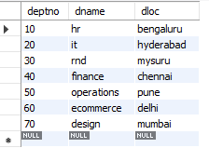
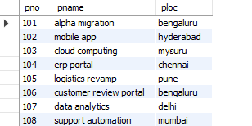
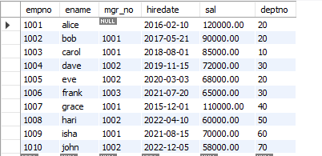
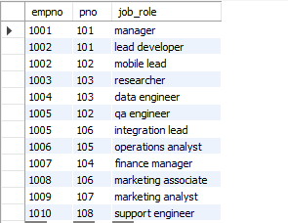
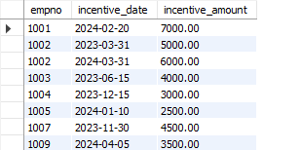
3. Retrieve the employee numbers of all employees who work on project located in Bengaluru, Hyderabad, or Mysuru
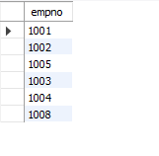
4. Get Employee ID’s of those employees who didn’t receive incentives
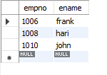
5. Write a SQL query to find the employees name, number, dept, job_role, department location and project location who are working for a project location same as his/her department location

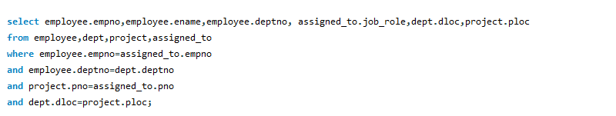
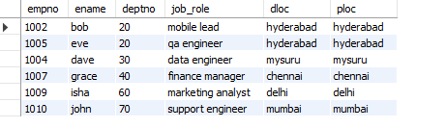

More queries on employee database

1.List employees with their department name & location
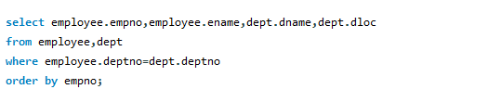
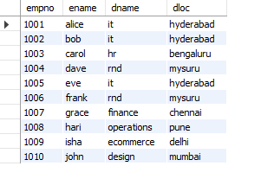
2.Employees who are not assigned to any project ,Project-wise headcount
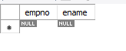
3.Department-wise average & max salary
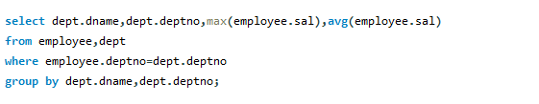
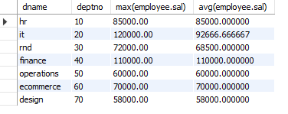
4. Total incentives earned by each employee (lifetime)
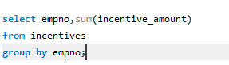
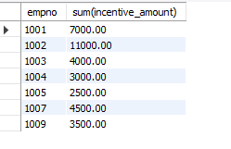
5. Employees working on a given project (project name :Alpha Project)
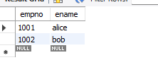
6. Departments with no employees
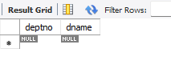
7. Managers and their direct report counts (MGR_NO references EMPNO)
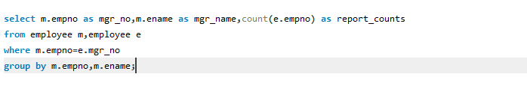
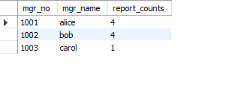
8. Employees assigned to more than one project.
